Cairo University  
Faculty of Computers and Information



**CS251**

**Software Engineering I**

GoFo

Software Design Specifications

Version 2.0

Mahmoud Mohamed Abdelazim : [mahmoud2011989@gmail.com](mailto:mahmoud2011989@gmail.com)

Ahmed Alaa Eldin : [Ahmedshikhtawel@gmail.com](mailto:Ahmedshikhtawel@gmail.com)

Amr Bumadian : [Amrbomadian8@gmail.com](mailto:Amrbomadian8@gmail.com)

April 2020

Contents

Team 3

Document Purpose and Audience 3

System Models 3

I. Class Diagram(s) 3

II. Class Descriptions 5

III. Sequence diagrams 5

Class - Sequence Usage Table 6

IV. User Interface Design 7

Tools 7

Ownership Report 7

References 7

Authors 7

# Team

|  |  |  |  |
| --- | --- | --- | --- |
| **ID** | **Name** | **Email** | **Mobile** |
| 20180263 | Mahmoud Mohamed Abdelazim | [Mahmoud2011989@gmail.com](mailto:Mahmoud2011989@gmail.com) | 01125401805 |
| 20180435 | Ahmed Alaa Eldin | [Ahmedshikhtawel@gmail.com](mailto:Ahmedshikhtawel@gmail.com) | 01142510014 |
| 20180436 | Amr Bumadian | [Amrbomadian8@gmail.com](mailto:Amrbomadian8@gmail.com) | 01032838645 |

# 

# Document Purpose and Audience

* **This document includes Software Design Specifications for GoFo football playground booking system. It describes the Class diagrams, Sequence diagrams and State diagrams.**
* **It is specially meant for developers that will work on the project in order to be organized.**

# 

# System Models

## I. Class Diagram(s)

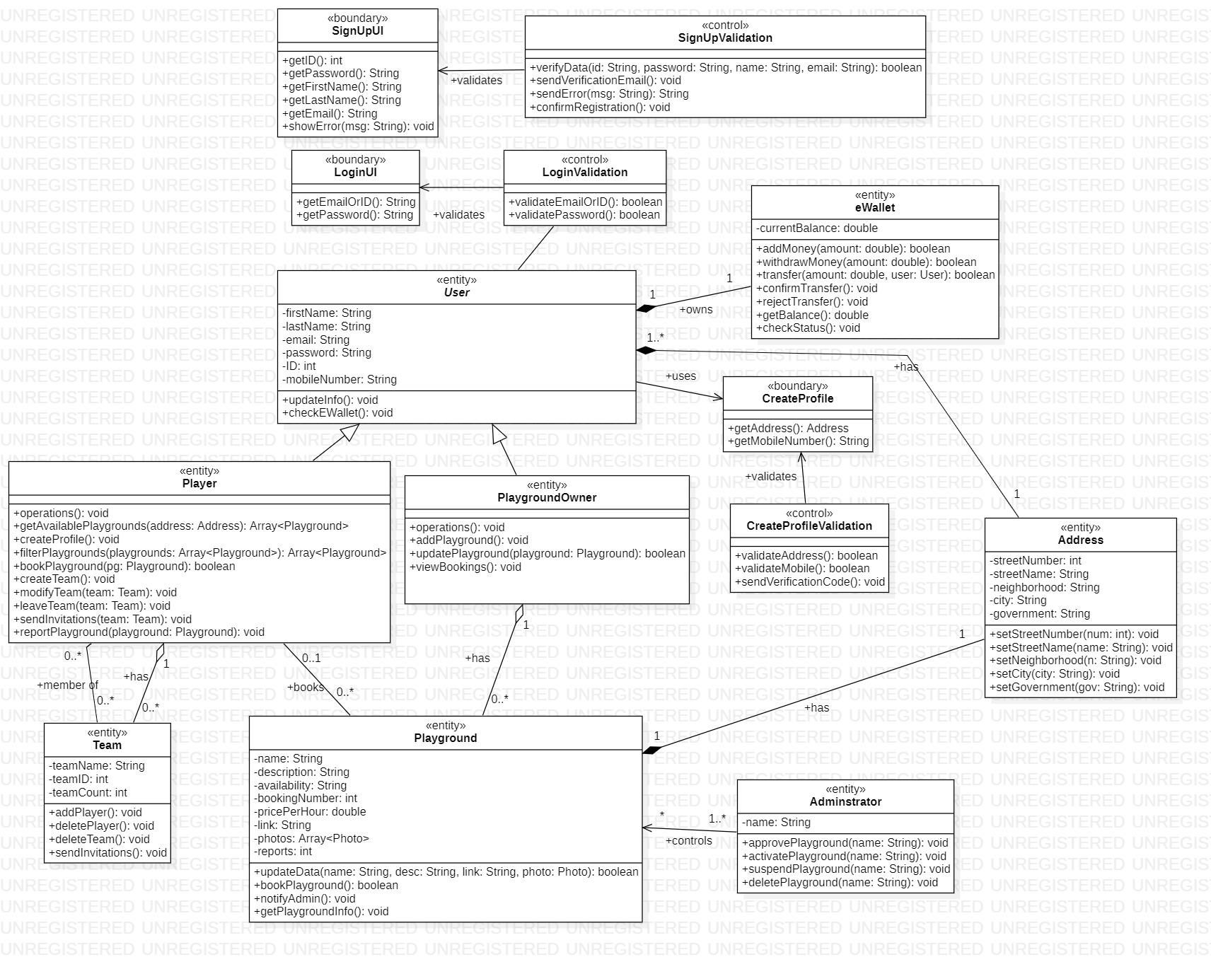

## 

## II. Class Descriptions

* **List down your classes and describe them**

| **Class ID** | **Class Name** | **Description & Responsibility** |
| --- | --- | --- |
| 1 | SignUpUI | A user interface to enable user to enter sign up information |
| 2 | SignUpValidation | A class to validate the information provided by the user to sign up |
| 3 | LoginUI | A user interface to enable the user to login to the system |
| 4 | LognValidation | A class to validate the information provided by the user in order to login, checks ID (or email) and password entered |
| 5 | User | An abstract class (generalization) that holds the common properties between a Player and a Playground Owner |
| 6 | Player | A class that inherits User, and allows player to book playgrounds and do player functionalities. |
| 7 | PlaygroundOwner | A class that inherits User, and allows an owner to add (own) playgrounds and control them |
| 8 | Playground | A class that hold the attributes and operations that is done on a Playground, and it is ownder by a PlaygroundOwner |
| 9 | Team | A class that is meant to group players together to form a team, and has a team owner Player and team member Players. |
| 10 | eWallet | A class that has the responsibility of controlling financial operations in the system, and can be connected to an outside method like Fawry, and any User must have one eWallet. |
| 11 | CreateProfile | A user interface to enable User to create a profile be submitting an Address and a phone number |
| 12 | CreateProfileValidation | A class to validate the information provided by the User in order to create a profile, by sending a verification code to the phone number and verifying it. |
| 13 | Address | A class that hold an address information divided into pieces in order to make the process of searching for playgrounds in a specific area easier, and it’s owned by Users. |
| 14 | Administrator | A class that can do special operations concerning playgrounds such as delete or suspend a playground |

## 

## III. Sequence diagrams

1. **Register a new user**

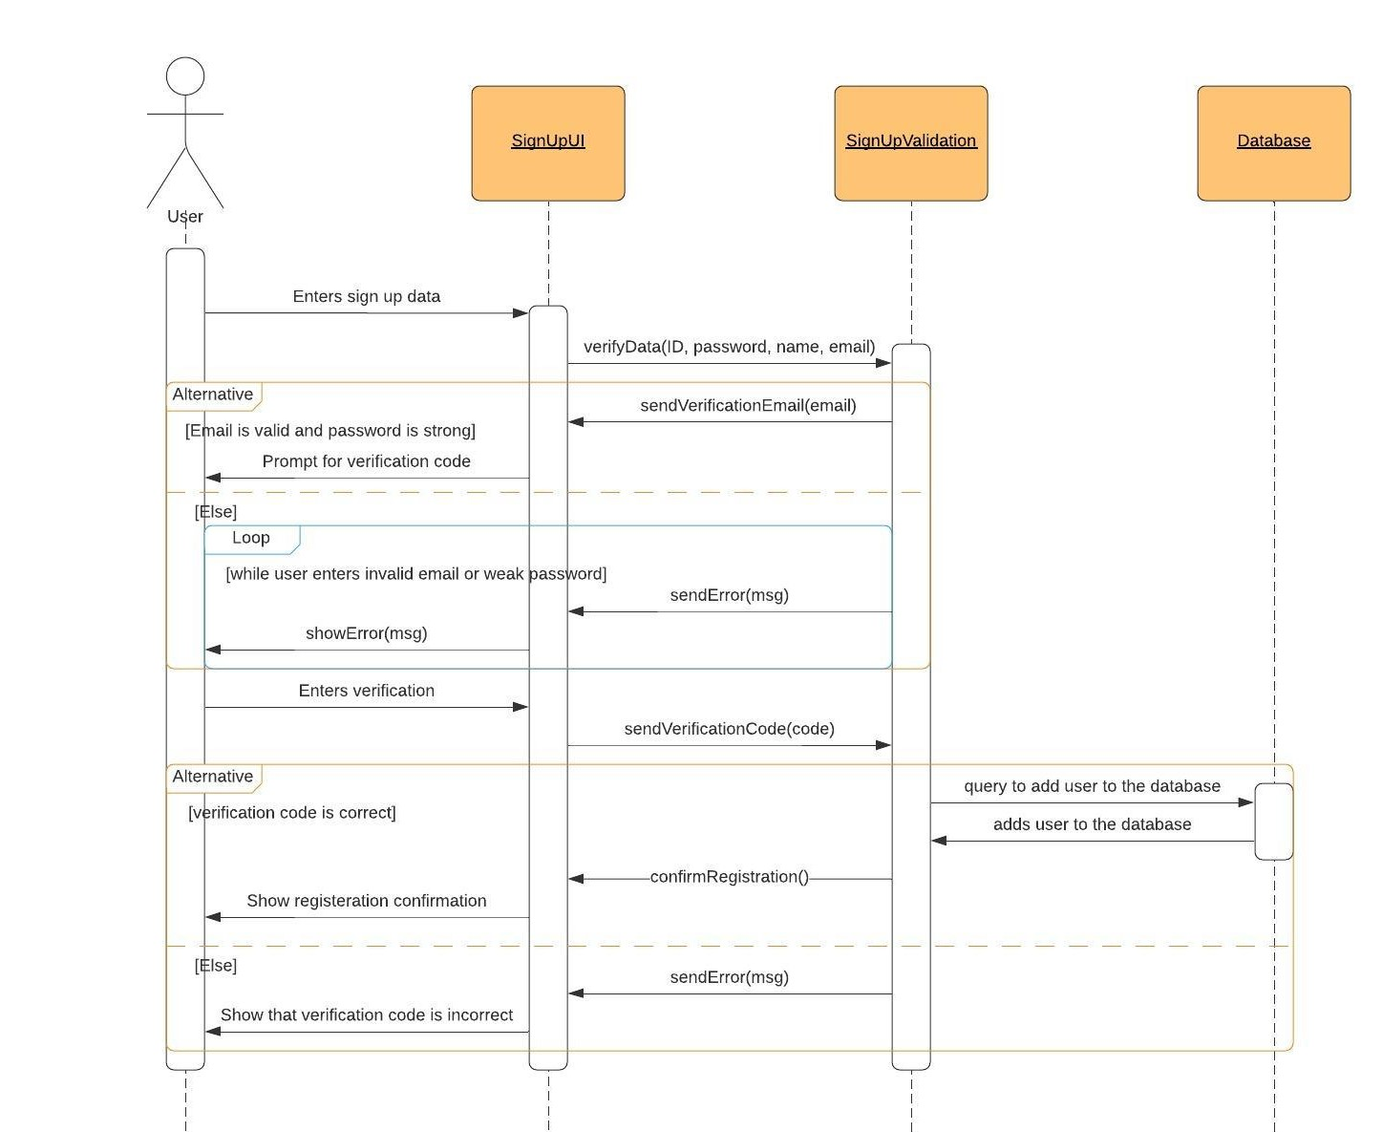

### 

### Add a Playground

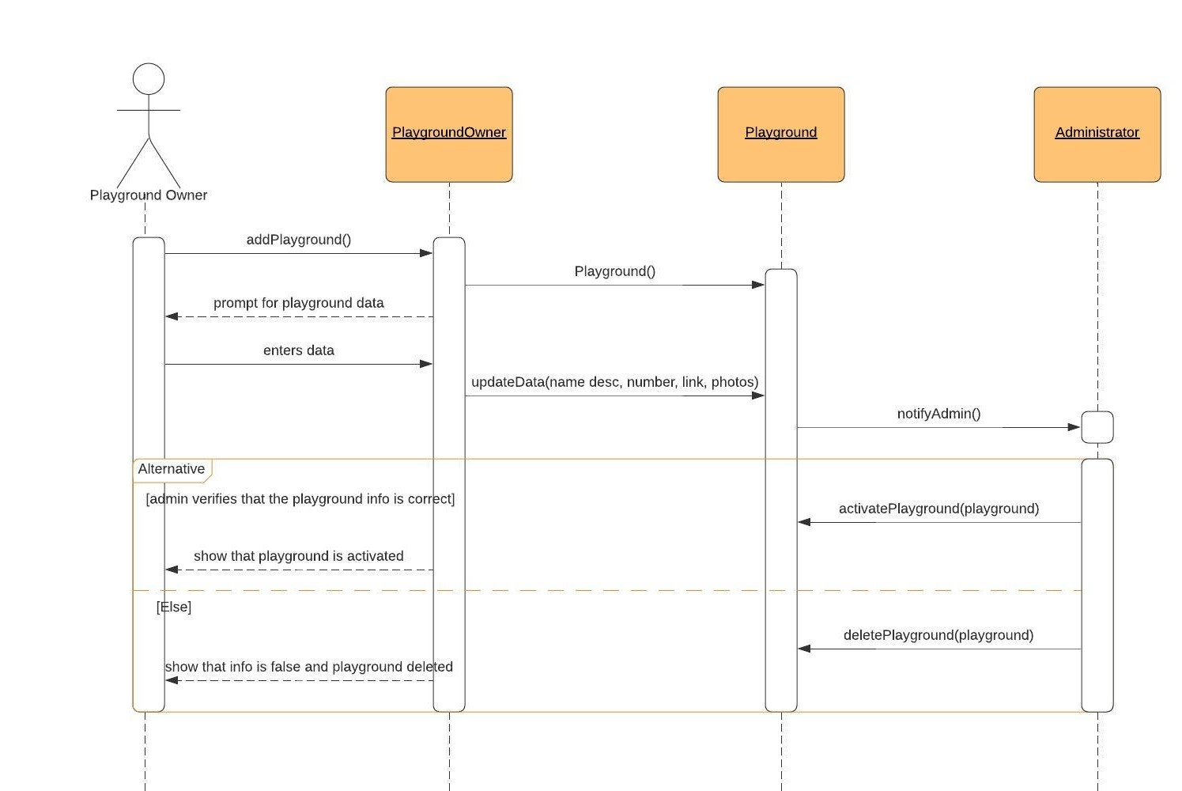

### Book a Playground

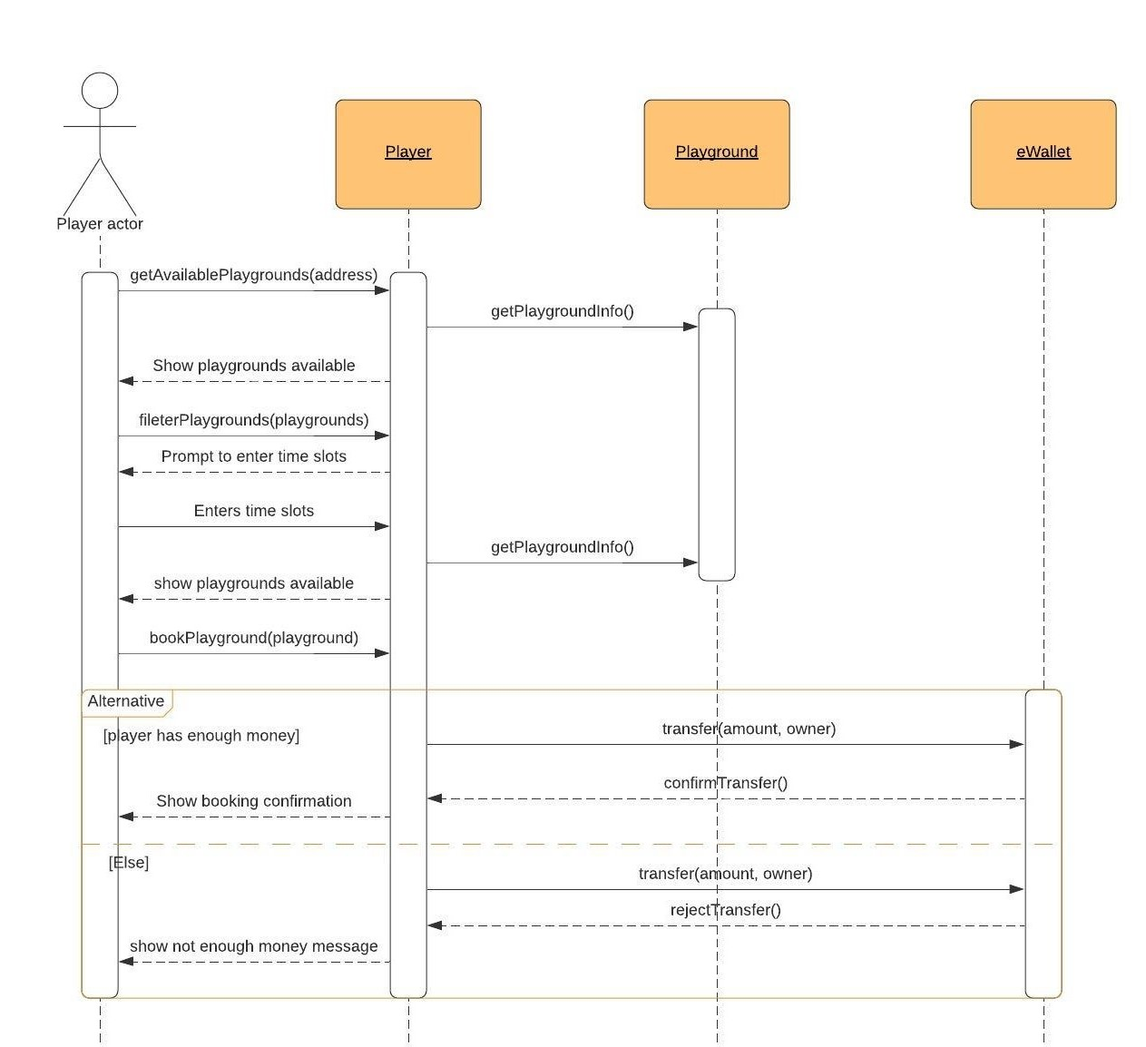

### Filter Playgrounds using time slots

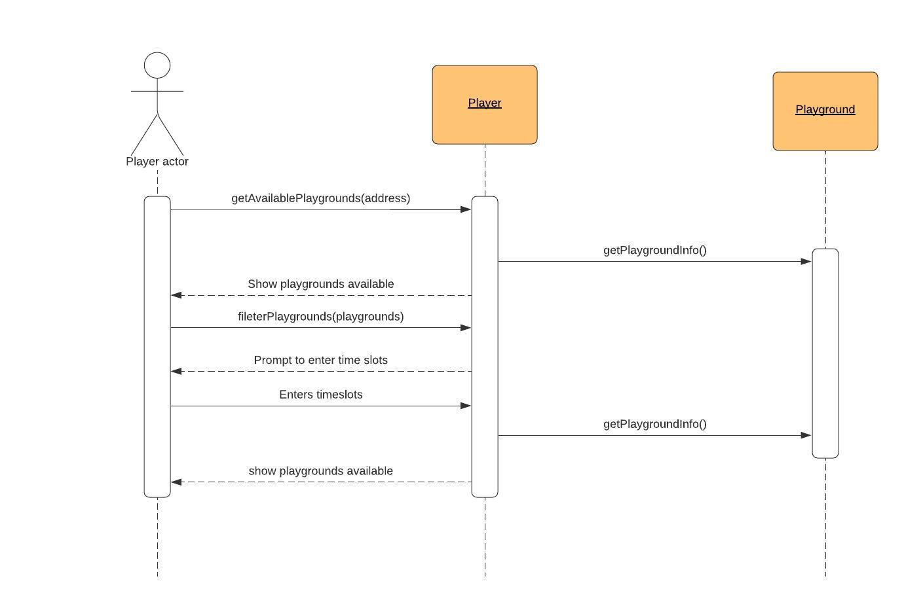

### Class - Sequence Usage Table

| **Sequence Diagram** | **Classes Used** | **All Methods Used** |
| --- | --- | --- |
| 1. Register a new user | Class SignUpUI  Class SignUpValidation | verifyData(ID, password, name, email)  sendVerificationEmail(email)  sendError(msg)  sendVertificationCode(code)  confirmRegistration() |
| 1. Add a Playground | Class PlaygroundOwner  Class Playground  Class Administrator | addPlayground()  updateData(name, desc, number, link, photos)  notifyAdmin()  activatePlayground(playground)  deletePlayground(playground) |
| 1. Book a Playground | Class Player  Class Playground  Class eWallet | getAvailablePlaygrounds(address)  getPlaygroundInfo()  filterPlaygrounds(playgrounds)  bookPlayground(playground)  transfer(amount, owner)  confirmTransfer()  rejectTransfer() |
| 1. Filter Playgrounds by timeslots | Class Player  Class Playground | getAvailablePlaygrounds(address)  getPlaygroundsInfo()  filterPlaygrounds(playgrounds) |

## 

## IV. User Interface Design

* **Provide a design of all the important screens of your system as wireframes or mockups. Use a tool to do that. Give each screen a number and name.**
* **Draw a navigation map that show how the screens are related (See example at** <https://stuff.mit.edu/afs/sipb/project/android/docs/training/design-navigation/wireframing.html>)
* **For each screen, describe what it does and what it is for.**

|  |  |  |
| --- | --- | --- |
| **Screen ID** | **Screen Name** | **Screen / Wireframe Description** |
|  |  |  |

# Tools

* **StarUML : Used in the Class Diagram**
* **LucidChart : Used in the Sequence Diagrams**

# Ownership Report

|  |  |
| --- | --- |
| **Item** | **Owners** |
| Part of Class Diagram, Sequence Diagrams 1 & 2, Part of GoFo Code | Mahmoud Mohamed Abdelazim |
| Part of Class Diagram, Part of GoFo Code, GoFo Code Sequence Diagrams | Ahmed Alaa Eldin |
| Sequence Diagrams 3 & 4, GoFo JavaDoc and UI Mockups | Amr Bumadian |

# References

* <http://www.mhhe.com/engcs/compsci/pressman/graphics/Pressman5sepa/common/cs1/design.pd>
* Mockups (<https://moqups.com/>).
* How to use Mockups <https://www.youtube.com/watch?v=glijkZFo4AY>
* Example wireframes and designs (you can contact the author for questions) <http://malakumar.com/wp-content/uploads/2018/12/MalaKumar_SampleWireframes-1.pdf>

# Authors

* Mostafa Saad and Mohammad El-Ramly (Edited by Mohamed Samir) (V1.0)
* Updated by Mohammad El-Ramly (V2.0)